**Executive Summary**

In order to identify the category to launch a new product, the customer engagement number is key, however, the frequency of the engagement is also equally important. Below is the findings from the analysis performed on account, customer, and transaction datasets that aims to find the best category for which the new product should be launched for.

**Findings**

Based on the analysis, the number of transactions in the transfer category are more than double the next category in the list. Looking further into the data, the average income of the customers performing the transactions is above $50,000 and $17,000 among the fulltime and parttime job holders, respectively. The overall engagement in the other categories are limited either to the certain gender or the customers with the full-time jobs which can potentially limit the reach of the product. Additionally, the frequency of transactions in the transfer category in the last 100 days is a good indication that the product will have a larger audience to support its initial launch.

Apart from the data itself, we know from the popularity of apps like venmo, zelle, square’s cash app, etc. , the transfer category is popular among the customers and has the likelihood of generating greater interest as more and more people engage in everyday banking through their mobile apps.

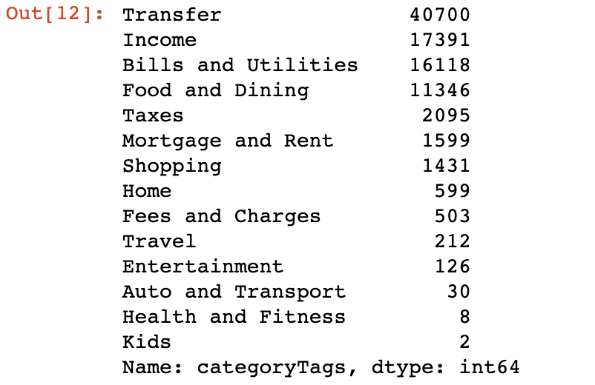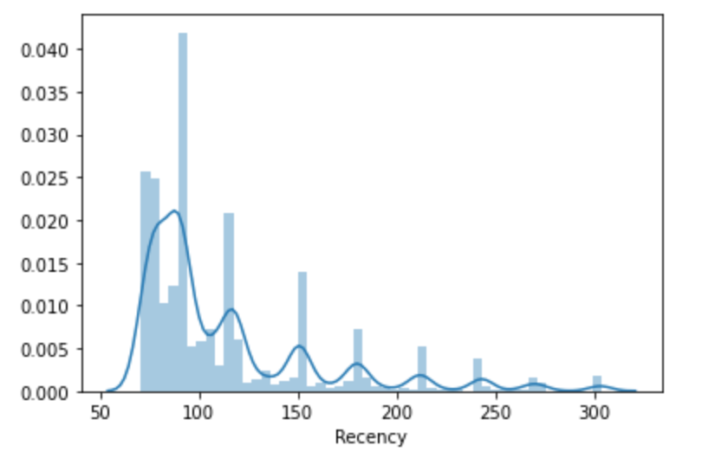

Fig. 1 Fig. 2

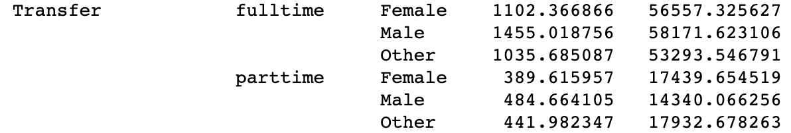

Fig. 3

**Recommendation**

Based on analysis, the recommendation is to target the new product for the customers in the transfer category. A k-means clustering analysis was performed to identify the suitable candidates for the new product. To perform the analysis, the customers were grouped by their ids and the transactions were analyzed to find out the frequency, recency, and the sum of amount transferred. Each customer recieved a certain numerical point based on the set criteria and were eventually given Platinum, Gold, Silver, and Bronze status that identified the likelihood of their engagement with our new product. Based on the analysis, there are 3 segments of the customer we should be targeting for the new product. They are represented by red, blue, and green dots in the chart below. The large number of customers in the red and blue category perform frequent transfer and the new product will likely be successful among them.

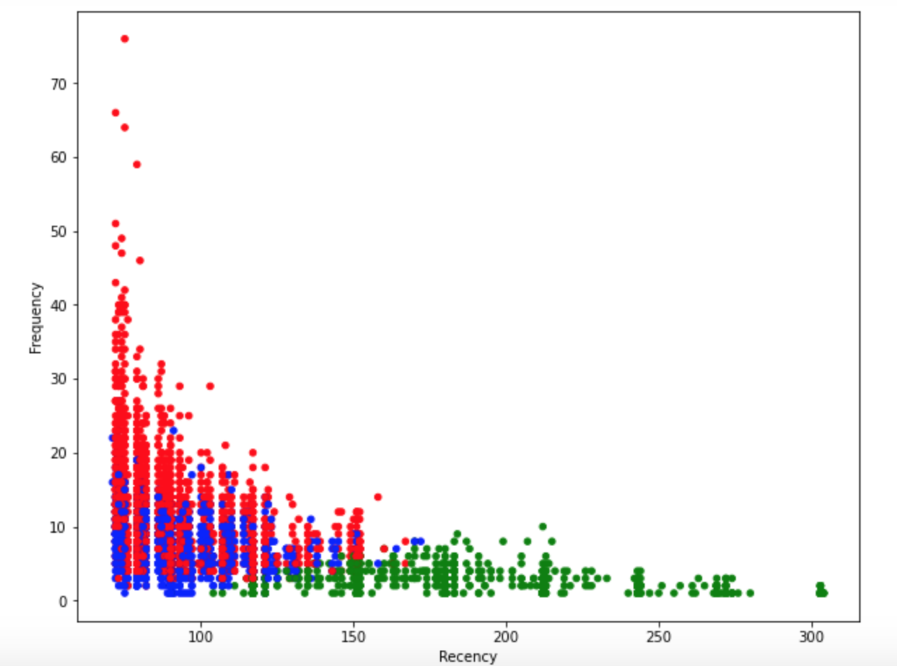

**Challenges and Risks**

The final output shows that the customers in the red segment should be the primary target for the new product as they represent the majority of the most frequent and engaged customers in the category. However, the risk of targeting just the red cluster may lead to potentially leaving out the customers that are, to many extent, have the same features as the customers in the red cluster. We can also see that the large number of blue segment customers overlap with the red segment ones, hence, it is likely that the blue cluster could contain false positives, and we can be missing out on the customers that are ideal targets for the new product.